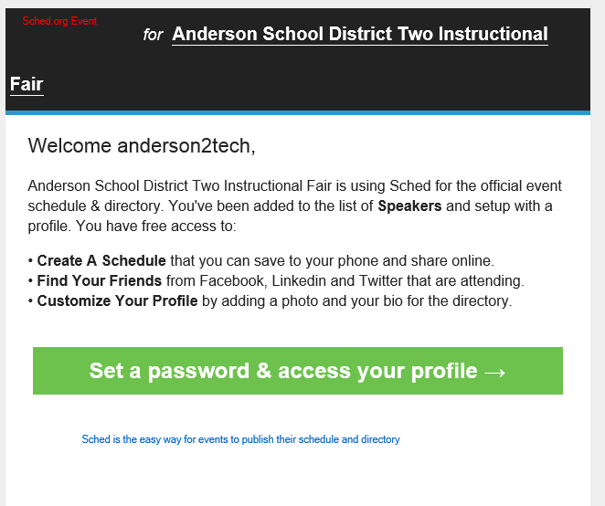
- Click on email from ‘Sched’.
- Click “set a password & access your profile”
- Create a password (consider writing this down for future use)
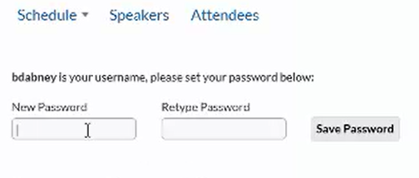

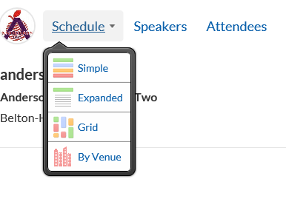
- Click “Schedule” and choose the simple lay out
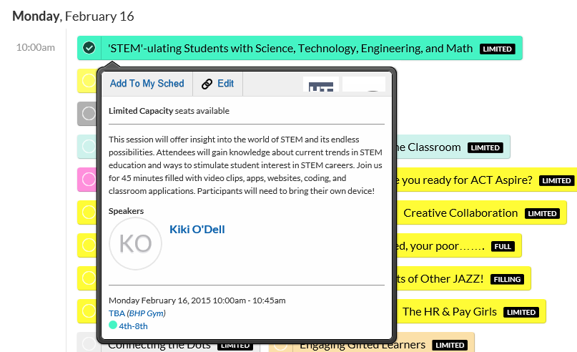
- Select which sessions you’d like to attend by checking the circle next to the corresponding session. (if you cannot select a session, you are not logged in!)

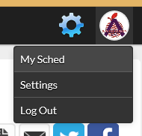
- After signing up for your sessions, you can click on your profile picture at the top right to view your schedule and an email confirmation sent to your inbox.

